str.rsplit(sep=None, maxsplit=-1)
Return a list of the words in the string, using sep as the delimiter string. If maxsplit is given, at most maxsplit splits are done, the rightmost ones. If sep is not specified or None, any whitespace string is a separator.

>>> str1="a,b,c,d,e"
>>> A=str1.split(sep=",")
>>> print(A)
['a', 'b', 'c', 'd', 'e']
>>> B=str1.rsplit(sep=",")
>>> print(B)
['a', 'b', 'c', 'd', 'e']
>>> C=str1.split(sep=",",maxsplit=2)
>>> print(C)
['a', 'b', 'c,d,e']
>>> D=str1.rsplit(sep=",",maxsplit=2)
>>> print(D)
['a,b,c', 'd', 'e']
>>> str2="a b c d e"
>>> A=str2.split()
>>> print(A)
['a', 'b', 'c', 'd', 'e']
>>> B=str2.rsplit()
>>> print(B)
['a', 'b', 'c', 'd', 'e']
>>> C=str2.rsplit(maxsplit=3)
>>> print(C)
['a b', 'c', 'd', 'e']

str.join(iterable, /)
Return a string which is the concatenation of the strings in iterable

Example
A=["x","y","z"]
s1=",".join(A)
print(A)
print(s1)
s2="".join(A)
print(s2)
s3=":".join(A)
print(s3)
B=["naresh","i","technologies"]
s4=" ".join(B)
print(B)
print(s4)

Output
['x', 'y', 'z']
x,y,z
xyz
x:y:z
['naresh', 'i', 'technologies']
naresh i technologies

#Reverse Words in a Given String in Python

'''
Given a string, the task is to reverse the words in it without
changing the words themselves.
For example, for "Learning Python is easy",
the reversed string would be "easy is Python Learning"
(words in reverse order).'''

str1="Learning Python is easy"
A=str1.split()
print(A)
A=A[::-1]
print(A)
str2=" ".join(A)
print(str2)
print(str1)

Example:
# Write a program to reverse each word in a given string
# "abc xyz pqr"
# "cba zyx rqp"

str1="abc xyz pqr"
A=str1.split()
B=[]
for s in A:
B.append(s[::-1])

print(A)
print(B)

str2=" ".join(B)
print(str1)
print(str2)

Output
['abc', 'xyz', 'pqr']
['cba', 'zyx', 'rqp']
abc xyz pqr
cba zyx rqp

Justification methods or alignment methods
String provides 3 justifications methods
- ljust()
- rjust()
- center()
These methods are used to format the string or output the given string with alignment.

str.ljust(width, fillchar=' ', /)
Return the string left justified in a string of length width. Padding is done using the specified fillchar (default is an ASCII space).

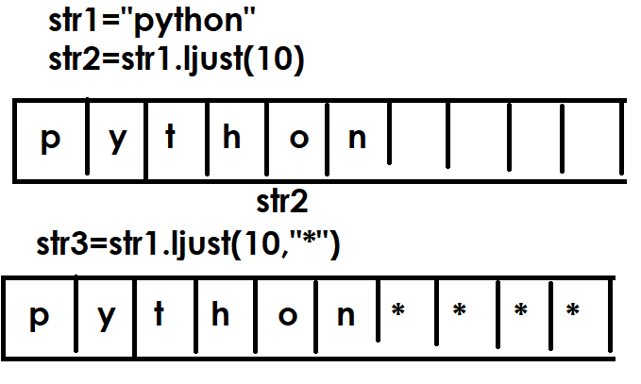

names=["naresh","kishore","kiran","raju","ramesh"]
for name in names:
print(name.ljust(15,"*"))

Output
naresh*********
kishore********
kiran**********
raju***********
ramesh*********

str.rjust(width, fillchar=' ', /)
Return the string right justified in a string of length width. Padding is done using the specified fillchar (default is an ASCII space)

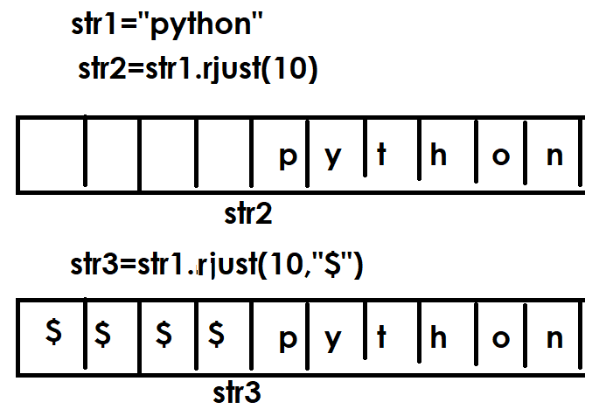
names=["naresh","kishore","kiran","raju","ramesh"]
for name in names:
print(name.rjust(15,"*"))

Output
*********naresh
********kishore
**********kiran
***********raju
*********ramesh

str.center(width, fillchar=' ', /)
Return centered in a string of length width. Padding is done using the specified fillchar (default is an ASCII space).

Example:
str1="abc"
str2=str1.center(9)
print(str1)
print(str2)
str3=str1.center(9,"*")
print(str3)
str4=str1.center(10,"$")
print(str4)

Output
abc
abc
***abc***
$$$abc$$$$

persons=[["naresh","nareshit@nareshit.com"],
["suresh","suresh@gmail.com"],
["kiran","kiran@nareshit.com"],
["raman","raman@gmail.com"]]
print("---------------------------------------------")
print("Name".ljust(10),"EmailID".center(20))
print("---------------------------------------------")
for p in persons:
print(p[0].ljust(10),p[1].center(20))

print("---------------------------------------------")

strip methods
string provides the following strip methods
- lstrip()
- rstrip()
- strip()

strip methods are used for removing or deleting leading or trailing spaces or given characters.

str.lstrip(chars=None, /)
Return a copy of the string with leading characters removed. The chars argument is a string specifying the set of characters to be removed. If omitted or None, the chars argument defaults to removing whitespace. The chars argument is not a prefix; rather, all combinations of its values are stripped:

>>> str1=" nit"
>>> print(len(str1))
7
>>> str2=str1.lstrip()
>>> print(str2)
nit
>>> print(str1)
nit
>>> print(len(str2))
3
>>> str3="******nit"
>>> str4=str3.lstrip("*")
>>> print(str3)
******nit
>>> print(str4)
nit
>>> str5="**&&&$$**nit"
>>> str6=str5.lstrip("*$&")
>>> print(str5)
**&&&$$**nit
>>> print(str6)
nit
>>> str7="n*i*t"
>>> str8=str7.lstrip("*")
>>> print(str7)
n*i*t
>>> print(str8)
n*i*t

str.rstrip(chars=None, /)
Return a copy of the string with trailing characters removed. The chars argument is a string specifying the set of characters to be removed. If omitted or None, the chars argument defaults to removing whitespace. The chars argument is not a suffix; rather, all combinations of its values are stripped

>>> str1="nit "
>>> str2=str1.rstrip()
>>> print(str1,len(str1))
nit 9
>>> print(str2,len(str2))
nit 3
>>> str3="nit****"
>>> str4=str3.rstrip("*")
>>> print(str4)
nit
>>> print(str3)
nit****
>>> str5="nit**%%$$**"
>>> str6=str5.rstrip("*%$")
>>> print(str5)
nit**%%$$**
>>> print(str6)
nit

str.strip(chars=None, /)
Return a copy of the string with the leading and trailing characters removed. The chars argument is a string specifying the set of characters to be removed. If omitted or None, the chars argument defaults to removing whitespace. The chars argument is not a prefix or suffix; rather, all combinations of its values are stripped

>>> str1=" nit "
>>> str2=str1.strip()
>>> print(str1,len(str1))
nit 10
>>> print(str2,len(str2))
nit 3
>>> str3="****nit*****"
>>> str4=str3.strip("*")
>>> print(str3,len(str3))
****nit***** 12
p
>>> print(str4,len(str4))
nit 3
>>> str5="**$$&&nit##@@**&"
>>> str6=str5.strip("*$&@#")
>>> print(str5)
**$$&&nit##@@**&
>>> print(str6)
nit

